INSTRUCTIONS FOR STUDENTS APPEARING FOR ND24 JKBOTE THEORY EXAMINATIONS AT
KASHMIR GOVT.POLYTECHNIC COLLEGE SRINAGAR
- Check the examination datesheet carefully. Make sure you know the correct date, time.
- The candidate shall report to the examination center half-an-hour before the time fixed for commencement of the examination.
- Do not bring any unauthorized material printed/written (e.g. notes, mobile phones, books, smart watches, other electronic gadgets). These will be confiscated and shall be considered as UNFAIR MEANS.
- Students are instructed to cross out the blank pages of their answer sheet before handing over the same to the invigilator.
- Students are required to comply with the instructions of exam invigilators/staff at all times.
- Students should carry hard copy of the downloaded admit card and college Identity card for appearing in the examination. If a student does not have their college ID card (which is required), they must bring another government-issued ID, such as an Aadhar card.
- Students are not allowed to leave the examination rooms in the first half time.
- No candidate should be allowed to enter the examination centre after the start of the examination.
- No supplementary answer book/continuation sheet will be provided.
- The Answer-Sheet OMR is divided into three parts marked as Part-I, Part-II and Part-III. The following information is to be filled up by the candidate across all these parts in legible form:
i. Session | iv. Branch
ii. Subject | v. Semester
iii. Paper Code | vi. Scheme

- In addition to these details, the candidate shall fill up the whole Part-III of OMR sheet, also known as Candidate Slip and put his/her signature in the box meant for the student signature (refer to figure 1). The Candidate Slip, also marked as Part-III on the OMR, should carry in a neat and legible form the Board Registration No., Name of the Candidate, Parentage, Institute Name, Date of Examination, Candidate Roll Number, Paper Code, Candidate Signature, Invigilator Signature, Name and Signature of Deputy Superintendent.
- Ask your genuine queries to the Examination staff deployed in your Exam Hall.

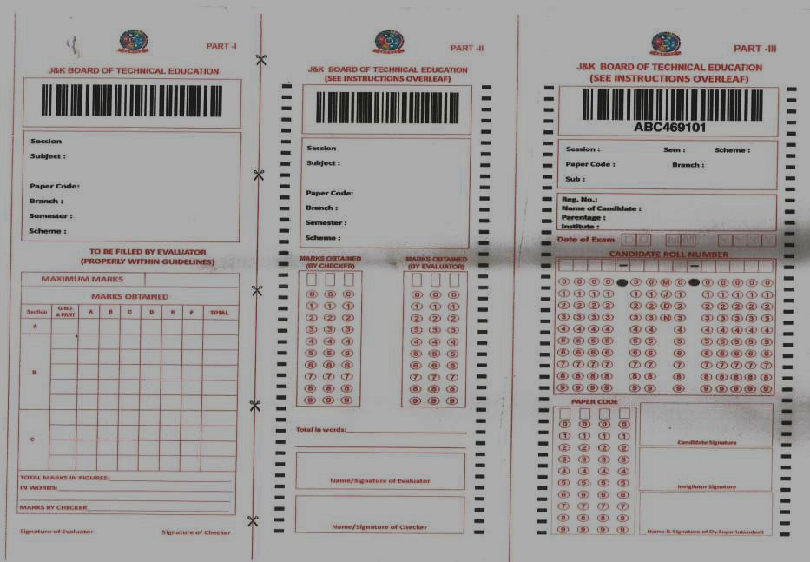

To be filled up by the student
To be filled up by the student
To be filled up by the student

Student shall put his sign here

Part-I Part-II Part-III (a.k.a. Candidate Slip)

Figure 1
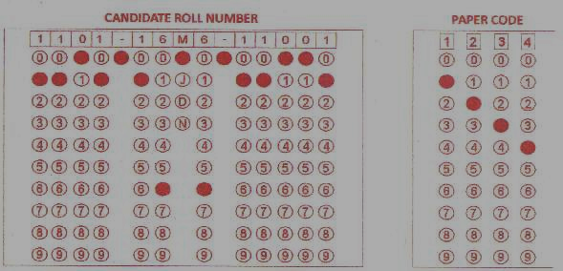
- The students should be careful while blackening out the circles under Roll Number and Paper Code as shown in the figure below.
Figure 2
- Students should ensure that they have marked their attendance on the Attendance sheets.

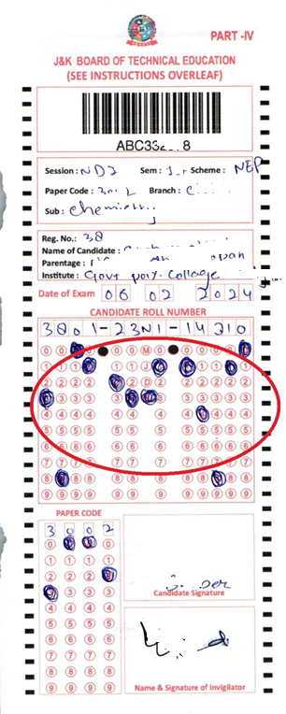
Some of the Common Mistakes which are to be avoided

Circles should be clearly
blackened out

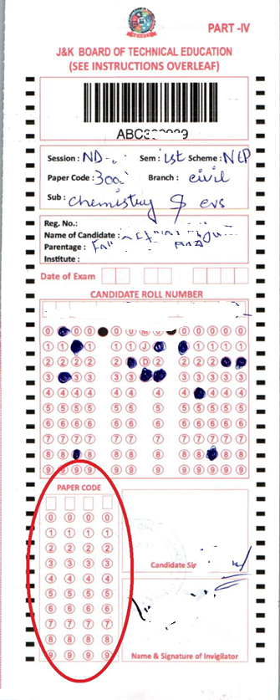

In one column only one circle is to be filled up

Paper Code and date shall not be left unfilled

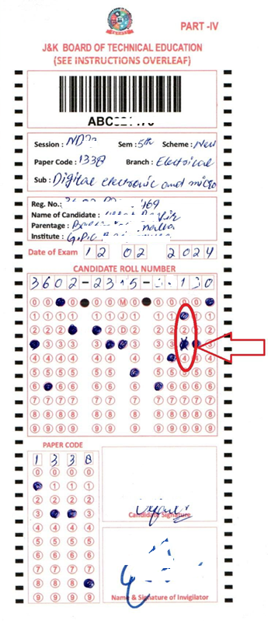

Corrections
/overwriting on OMR is not allowed

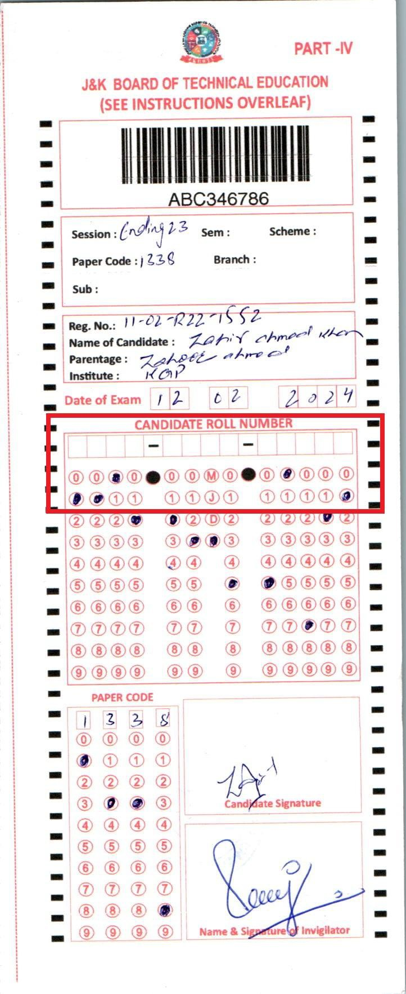

Roll Number should NOT be left blank.

